PUEUMATIC ACTUATORS SERIES AT Series Valve Pneumatic Actuator

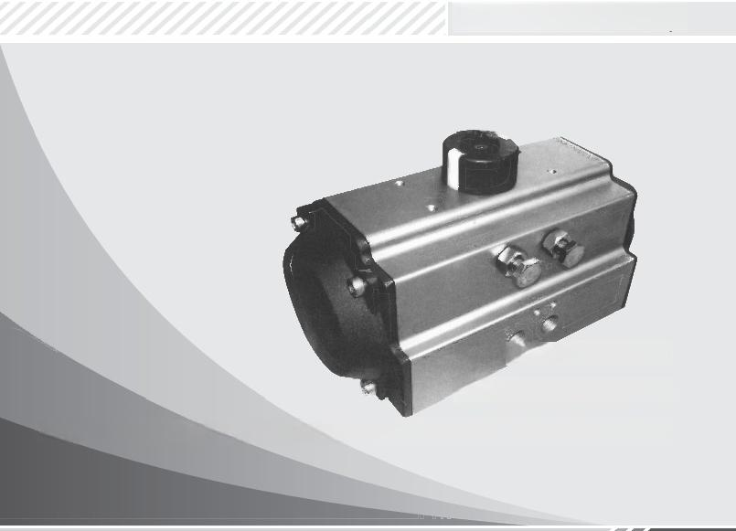
Selection and Operation Manual

101010100101
0101011010101001011010100101

一. Design & Features
The AT series pneumatic actuators are developed and designed based on the comprehensive application of new domestic and international technologies, new materials, new processes, and innovative concepts, with the following features:
★ Fully compliant with the latest international standards: ISO5211, DIN3337, VDI/VDE3845, and NAMUR.
★ Extruded high-strength aluminum cylinder block with finely ground and hard anodized inner surface, ensuring long service life, low friction coefficient, and fast response.
★ Elegant, compact, and modern design, with a full range of specifications for cost-effective selection.
★ High-quality bearings on all moving surfaces, realizing low friction, long service life, and noise-free operation.
★ Two independent external travel adjustment mechanisms for convenient ±5° calibration at full-open or full-closed positions.
★ Actuators with the same external structure are available in double-acting or single-acting (spring return) types; single-acting type offers normally closed (NC) or normally open (NO) options.
★ NAMUR-standard multi-functional position indicator for visual status display, and easy installation/output of all accessories.
★ Pre-compressed load springs for safe and convenient installation and disassembly.

★ Die-cast aluminum alloy pistons and end caps, featuring high strength and light weight.
★ Compatible with high-temperature or low-temperature applications by changing the seal material.
★ Various angular strokes (e.g., 120°, 135°, 180°, etc.) and three-position pneumatic actuators are available upon request. Solenoid valves can be directly mounted without adapter plates.

二. Operating Conditions

Operating Medium
Clean, dry, or lubricated air or inert gas; non-corrosive gases compatible with internal components and lubricants of the actuator. The dew point temperature of the medium is -20℃. The particle size of impurities in the medium shall not exceed 30μm. When a positioner is used, the particle size of impurities in the medium shall not exceed 5μm.

Supply Pressure
- 3bar to 8bar

Operating Ambient Temperature
- Standard type: -20℃ to +80℃
- Low-temperature type: -40℃ to +80℃
- High-temperature type: -20℃ to +160℃

Lubrication
Under normal operating conditions, the standard type requires no additional lubrication. For low-temperature or high-temperature applications, special lubricants are required.

三. Appearance and Key Dimensions Chart
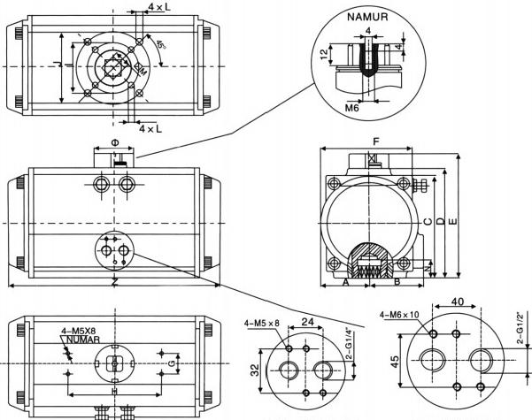
G1/4”NUMAR 标准 G1/2"NUMAR 标准

type | A | B | C | D | E | F | H | I | N | J | K | L | M | air supply interface
AT032 | 110 | 45 | 45 | 65 | 22.5 | 22.5 | 50 | 25 | 9 | F03 |  | M5X7.5 |  | NAMURG1/8"
AT052 | 160 | 72 | 65 | 92 | 30 | 41.5 | 80 | 30 | 11 | F05 | F03 | M6X10 | M5X7.5 | NAMURG1/4"
AT063 | 190 | 88 | 72 | 108 | 36 | 47 | 80 | 30 | 14 | F07 | F05 | M8X13 | M6X10 | NAMURG1/4"
AT075 | 206 | 100 | 81 | 120 | 42 | 53 | 80 | 30 | 14 | F07 | F05 | M8X13 | M6X10 | NAMURG1/4"
AT083 | 216 | 109 | 92 | 129 | 46 | 57 | 80 | 30 | 17 | F07 | F05 | M8X13 | M6X10 | NAMURG1/4"
AT092 | 260 | 117 | 98 | 137 | 50 | 58.5 | 80 | 30 | 17 | F07 | F05 | M8X13 | M6X10 | NAMURG1/4"
AT105 | 286 | 133 | 110 | 153 | 58 | 62 | 80 | 30 | 22 | F10 | F07 | M10X16 | M8X13 | NAMURG1/4"
AT125 | 340 | 155 | 125.5 | 175 | 67.5 | 75 | 80 | 30 | 22 | F10 | F10 | M10X16 | M8X13 | NAMURG1/4"
AT140 | 412 | 173 | 137.5 | 193 | 75 | 77 | 80 | 30 | 27 | F12 | F10 | M12X20 | M10X16 | NAMURG1/4"
AT160 | 480 | 198 | 158 | 218 | 87 | 87 | 80 | 30 | 27 | F12 | F10 | M12X20 | M10X16 | NAMURG1/4"
AT190 | 538 | 232 | 189 | 262 | 103 | 103 | 130 | 30 | 36 | F14 |  | M16X24 |  | NAMURG1/4"
AT210 | 568 | 257 | 210 | 287 | 113 | 113 | 130 | 30 | 36 | F14 |  | M16X24 |  | NAMURG1/4"

四 、parts and Material
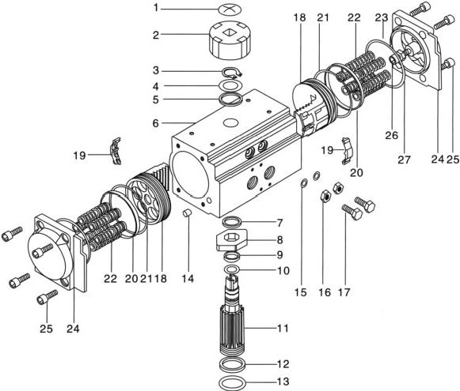

Item No. | Part Name | Quantity | Material | Anti-Corrosion Treatment | Optional Materials
1 | Indicator Screw | 1 | Plastic | - | -
2 | Indicator | 1 | Plastic | - | -
3 | Circlip | 1 | Stainless Steel | - | -
4 | Washer | 1 | Stainless Steel | - | -
5 | Outer Gasket | 1 | Engineering Plastic | - | -
6 | Cylinder Block | 1 | Cast Aluminum | Hard Anodization, etc. | -
7 | Inner Gasket | 1 | Engineering Plastic | - | -
8 | Cam | 1 | Alloy Steel | - | -
9 | Upper Shaft Bearing | 1 | Engineering Plastic | - | -
10 | Upper Shaft O-Ring | 1 | Nitrile Rubber (NBR) | - | Fluororubber (FKM)/Silicone Rubber
11 | Gear Shaft | 1 | Alloy Steel | Nickel Plating | Stainless Steel
12 | Lower Shaft Bearing | 1 | Engineering Plastic | - | -
13 | Lower Shaft O-Ring | 2 | Nitrile Rubber (NBR) | - | Fluororubber (FKM)/Silicone Rubber
14 | Plug | 2 | Nitrile Rubber (NBR) | - | Fluororubber (FKM)/Silicone Rubber
15 | Adjusting Screw O-Ring | 2 | Nitrile Rubber (NBR) | - | Fluororubber (FKM)/Silicone Rubber
16 | Adjusting Screw Nut | 2 | Stainless Steel | - | -
17 | Adjusting Bolt | 2 | Stainless Steel | - | -
18 | Piston | 2 | Cast Aluminum/Cast Steel | Anodization/Galvanization | Stainless Steel
19 | Piston Guide Plate | 2 | Engineering Plastic | - | -
20 | Piston Bearing | 2 | Engineering Plastic | - | -
21 | Piston O-Ring | 2 | Nitrile Rubber (NBR) | - | Fluororubber (FKM)/Silicone Rubber
22 | Spring | 0~12 | Spring Steel | Paint Dipping | -
23 | End Cover O-Ring | 2 | Nitrile Rubber (NBR) | - | Fluororubber (FKM)/Silicone Rubber
24 | End Cover | 2 | Cast Aluminum | Powder Coating, etc. | -
25 | End Cover Bolt | 8 | Stainless Steel | - | -
26 | Limit Bolt | 2 | Stainless Steel | - | -
27 | Limit Nut | 2 | Stainless Steel | - | -

五．Double-Acting Actuator Output Torque

Double-Acting Actuator Torque Diagram
type Model | Input Supply Pressure (Unit: bar)
type Model | 3.0 | 4.0 | 5.0 | 6.0 | 7.0 | 8.0
type Model | Air Supply Input Torque (Nm)
AT032 | 4.8 | 6.1 | 7.6 | 9.2 | 10.7 | 12.2
AT052 | 12.0 | 16.0 | 20.0 | 24.0 | 28.0 | 32.0
AT063 | 21.7 | 28.9 | 36.1 | 43.4 | 50.6 | 57.8
AT075 | 35.0 | 46.6 | 58.3 | 69.9 | 81.6 | 93.2
AT083 | 42.8 | 57.0 | 71.3 | 85.5 | 99.8 | 114.0
AT092 | 67.6 | 90.1 | 112.6 | 135.2 | 157.7 | 180.2
AT105 | 97.7 | 130.3 | 162.9 | 195.5 | 228.0 | 260.6
AT125 | 173.3 | 231.0 | 288.8 | 346.5 | 404.3 | 462.0
AT140 | 260.7 | 347.6 | 434.5 | 521.4 | 608.3 | 695.2
AT160 | 397.2 | 529.6 | 662.0 | 794.4 | 926.8 | 1059.2
AT190 | 640.2 | 853.6 | 1067.0 | 1280.4 | 1493.8 | 1707.2
AT210 | 798.0 | 1064.0 | 1330.0 | 1596.0 | 1862.0 | 2128.0

Output Torque of Single-Acting Actuator

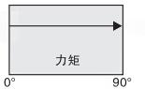
Starting Point End Point

Single-Acting Torque Diagram
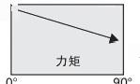
Starting Point下
End point
cylinder
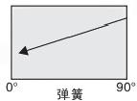
Starting Point

End Point

Model | Spring Force | Spring Pre-compression (Nm) |  | Input Supply Pressure (Unit: bar)
Model | Spring Force |  |  | 3.0 |  | 4.0 |  | 5.0 |  | 6.0 |  | 7.0
Model | Spring Force |  |  | Air Supply Output Torque (Nm)
Model | Spring Force | 0° | 90° | 0° | 90° | 0° | 90° | 0° | 90° | 0° | 90° | 0° | 90°
AT052 | 5 | 4.0 | 6.2 | 8.1 | 5.8 | 12.1 | 9.8
AT052 | 6 | 4.7 | 7.4 | 7.3 | 4.6 | 11.3 | 8.6
AT052 | 7 | 5.5 | 8.7 | 6.5 | 3.3 | 10.5 | 7.3 | 14.5 | 11.3
AT052 | 8 | 6.3 | 9.9 |  |  | 9.7 | 6.1 | 13.7 | 10.1
AT052 | 9 | 7.1 | 11.2 |  |  | 8.9 | 4.8 | 12.9 | 8.8 | 16.9 | 12.8
AT052 | 10 | 7.9 | 12.4 |  |  | 8.1 | 3.6 | 12.1 | 7.6 | 16.1 | 11.6 | 20.1 | 15.6
AT052 | 11 | 8.7 | 13.6 |  |  | 7.3 | 2.4 | 11.3 | 6.4 | 15.3 | 10.4 | 19.3 | 14.4
AT052 | 12 | 9.5 | 14.9 |  |  |  |  | 10.5 | 5.1 | 14.5 | 9.1 | 18.5 | 13.1
AT063 | 5 | 6.8 | 10.4 | 14.9 | 11.3 | 22.1 | 18.5
AT063 | 6 | 8.2 | 12.5 | 13.5 | 9.2 | 20.7 | 16.4
AT063 | 7 | 9.6 | 14.6 | 12.1 | 7.1 | 19.3 | 14.3 | 26.5 | 21.5
AT063 | 8 | 10.9 | 16.7 |  |  | 18.0 | 12.2 | 25.2 | 19.4
AT063 | 9 | 12.3 | 18.9 |  |  | 16.6 | 10.0 | 23.8 | 17.2 | 31.1 | 24.5
AT063 | 10 | 13.7 | 20.9 |  |  | 15.2 | 8.0 | 22.4 | 15.2 | 29.7 | 22.5 | 36.9 | 29.7
AT063 | 11 | 15.0 | 22.9 |  |  |  |  | 21.1 | 13.2 | 28.4 | 20.5 | 35.6 | 27.7
AT063 | 12 | 16.4 | 25.0 |  |  |  |  | 19.7 | 11.1 | 27.0 | 18.4 | 34.2 | 25.6
AT075 | 5 | 10.5 | 16.3 | 24.5 | 18.8 | 36.1 | 30.4
AT075 | 6 | 12.7 | 19.5 | 22.3 | 15.5 | 33.9 | 27.1
AT075 | 7 | 14.8 | 22.8 | 20.2 | 12.3 | 31.8 | 23.9
AT075 | 8 | 16.9 | 26.0 |  |  | 29.7 | 20.6 | 41.4 | 32.2
AT075 | 9 | 19.0 | 29.3 |  |  | 27.6 | 17.4 | 39.3 | 29.1 | 50.9 | 40.7
AT075 | 10 | 21.1 | 32.5 |  |  | 25.5 | 14.1 | 37.2 | 25.8 | 48.8 | 37.4 | 60.5 | 49.1
AT075 | 11 | 23.2 | 35.8 |  |  | 23.4 | 10.9 | 35.1 | 22.6 | 46.7 | 34.2 | 58.4 | 45.9
AT075 | 12 | 25.3 | 39.0 |  |  |  |  | 33.0 | 19.3 | 44.6 | 30.9 | 56.3 | 42.6

六、Output Torque of Single-Acting Actuator

Model | Spring Force | Spring Pre-compression (Nm) |  | Input Supply Pressure (Unit: bar)
Model | Spring Force |  |  | 3.0 |  | 4.0 |  |  | 5.0 |  |  | 6.0 |  |  |  | 7.0
Model | Spring Force |  |  | Air Supply Output Torque (Nm)
Model | Spring Force | 0° | 90° | 0° | 90° |  | 0° | 90° |  | 0° | 90° |  | 0° | 90° | 0° |  | 90°
AT83 | 5 | 14.8 | 20.6 | 28.1 | 22.3 |  | 42.3 | 36.5
AT83 | 6 | 17.7 | 24.7 | 25.1 | 18.1 |  | 39.3 | 32.3
AT83 | 7 | 20.7 | 28.8 |  |  |  | 36.4 | 28.2 |  | 50.7 | 42.5
AT83 | 8 | 23.6 | 32.9 |  |  |  | 33.4 | 24.1 |  | 47.7 | 38.4
AT83 | 9 | 26.6 | 37.0 |  |  |  | 30.5 | 20.0 |  | 44.8 | 34.4 |  | 59.0 | 48.5
AT83 | 10 | 29.5 | 41.1 |  |  |  | 27.5 | 15.9 |  | 41.8 | 30.2 |  | 56.0 | 44.4 | 70.3 |  | 58.7
AT83 | 11 | 32.5 | 45.2 |  |  |  |  |  |  | 38.9 | 26.1 |  | 53.1 | 40.3 | 67.4 |  | 54.6
AT83 | 12 | 35.4 | 49.3 |  |  |  |  |  |  | 35.9 | 22.0 |  | 50.1 | 36.2 | 64.4 |  | 50.5
AT92 | 5 | 23.0 | 33.0 | 44.6 | 34.7 |  | 67.1 | 57.2
AT92 | 6 | 27.6 | 39.5 | 40.0 | 28.1 |  | 62.5 | 50.6
AT92 | 7 | 32.2 | 46.1 |  |  |  | 57.9 | 44.0 |  | 80.4 | 66.5
AT92 | 8 | 36.8 | 52.7 |  |  |  | 53.3 | 37.4 |  | 75.8 | 59.9
AT92 | 9 | 41.4 | 59.3 |  |  |  | 48.7 | 30.8 |  | 71.2 | 53.3 |  | 93.8 | 75.9
AT92 | 10 | 46.0 | 65.9 |  |  |  | 44.1 | 24.2 |  | 66.6 | 46.7 |  | 89.2 | 69.3 | 111.7 |  | 91.8
AT92 | 11 | 50.6 | 72.5 |  |  |  |  |  |  | 62.0 | 40.1 |  | 84.6 | 62.7 | 107.1 |  | 85.2
AT92 | 12 | 55.2 | 79.1 |  |  |  |  |  |  | 57.4 | 33.5 |  | 80.0 | 56.1 | 102.5 |  | 78.6
AT105 | 5 | 31.8 | 49.3 | 66.0 | 48.4 |  | 98.6 | 81.0
AT105 | 6 | 38.1 | 59.2 | 59.6 | 38.5 |  | 92.2 | 71.1
AT105 | 7 | 44.5 | 69.0 |  |  |  | 85.9 | 61.3 |  | 118.5 | 93.9
AT105 | 8 | 50.8 | 78.9 |  |  |  | 79.5 | 51.4 |  | 112.1 | 84.0
AT105 | 9 | 57.2 | 88.7 |  |  |  | 73.2 | 41.6 |  | 105.8 | 74.2 |  | 138.4 | 106.8
AT105 | 10 | 63.5 | 98.6 |  |  |  | 66.8 | 31.7 |  | 99.4 | 64.3 |  | 132.0 | 96.9 | 164.5 |  | 129.4
AT105 | 11 | 69.9 | 108.5 |  |  |  |  |  |  | 93.1 | 54.4 |  | 125.7 | 87.0 | 158.2 |  | 119.5
AT105 | 12 | 76.2 | 118.3 |  |  |  |  |  |  | 86.7 | 44.6 |  | 119.3 | 77.2 | 151.8 |  | 109.7
AT125 | 5 | 52.5 | 86.3 | 121 | 87 |  | 179 | 145
AT125 | 6 | 63.0 | 103.5 | 110 | 70 |  | 168 | 128
AT125 | 7 | 73.5 | 120.8 |  |  |  | 158 | 110 |  | 215 | 168
AT125 | 8 | 84.0 | 138.0 |  |  |  | 147 | 93 |  | 205 | 151
AT125 | 9 | 94.5 | 155.3 |  |  |  | 137 | 76 |  | 194 | 134 |  | 252 | 191
AT125 | 10 | 105.0 | 172.5 |  |  |  | 126 | 59 |  | 184 | 116 |  | 245 | 174 | 299 |  | 232
AT125 | 11 | 115.5 | 189.8 |  |  |  |  |  |  | 173 | 99 |  | 231 | 157 | 289 |  | 214
AT125 | 12 | 126.0 | 207.0 |  |  |  |  |  |  | 163 | 82 |  | 221 | 140 | 278 |  | 197
AT140 | 5 | 86.0 | 129.0 | 174 | 131 |  | 261 | 218
AT140 | 6 | 103.2 | 154.8 | 157 | 105 |  | 244 | 192
AT140 | 7 | 120.4 | 180.6 |  |  |  | 227 | 166 |  | 314 | 253
AT140 | 8 | 137.6 | 206.4 |  |  |  | 209 | 141 |  | 296 | 228
AT140 | 9 | 154.8 | 232.2 |  |  |  | 192 | 115 |  | 279 | 202 |  | 366 | 289
AT140 | 10 | 172.0 | 258.0 |  |  |  | 175 | 89 |  | 262 | 176 |  | 349 | 263 | 436 |  | 350
AT140 | 11 | 189.2 | 283.8 |  |  |  |  |  |  | 245 | 150 |  | 332 | 237 | 585 |  | 324
AT140 | 12 | 206.4 | 309.6 |  |  |  |  |  |  | 228 | 124 |  | 315 | 211 | 402 |  | 298

七、Output Torque of Single-Acting Actuator

Model | Spring Force | Spring Pre-compression (Nm) |  | Input Supply Pressure (Unit: bar)
Model | Spring Force |  |  | 3.0 |  |  | 4.0 |  | 5.0 |  |  | 6.0 |  |  |  | 7.0
Model | Spring Force |  |  | Air Supply Output Torque (Nm)
Model | Spring Force | 0° | 90° | 0° | 90° | 0° |  | 90° |  | 0° | 90° |  | 0° | 90° | 0° |  | 90°
AT160 | 5 | 139.5 | 192.5 | 258 | 205 | 390 |  | 337
AT160 | 6 | 167.4 | 231.0 | 230 | 166 | 362 |  | 298
AT160 | 7 | 195.3 | 269.5 |  |  | 334 |  | 260 |  | 467 | 393
AT160 | 8 | 223.2 | 308.0 |  |  | 306 |  | 221 |  | 469 | 354
AT160 | 9 | 251.1 | 346.5 |  |  | 278 |  | 183 |  | 411 | 316 |  | 543 | 448
AT160 | 10 | 279.0 | 385.0 |  |  | 250 |  | 144 |  | 383 | 277 |  | 515 | 409 | 647 |  | 541
AT160 | 11 | 306.9 | 423.5 |  |  |  |  |  |  | 355 | 239 |  | 487 | 371 | 619 |  | 503
AT160 | 12 | 334.8 | 462.0 |  |  |  |  |  |  | 327 | 200 |  | 459 | 332 | 591 |  | 464
AT190 | 5 | 200 | 320 | 440 | 320 | 653 |  | 533
AT190 | 6 | 240 | 384 | 400 | 256 | 613 |  | 469
AT190 | 7 | 280 | 448 |  |  | 573 |  | 405 |  | 787 | 619
AT190 | 8 | 320 | 512 |  |  | 533 |  | 341 |  | 747 | 555
AT190 | 9 | 360 | 576 |  |  | 493 |  | 277 |  | 707 | 491 |  | 920 | 704
AT190 | 10 | 400 | 640 |  |  | 453 |  | 213 |  | 667 | 427 |  | 880 | 640 | 1093 |  | 853
AT190 | 11 | 440 | 704 |  |  |  |  |  |  | 627 | 393 |  | 840 | 576 | 1053 |  | 789
AT190 | 12 | 480 | 768 |  |  |  |  |  |  | 587 | 299 |  | 800 | 512 | 1013 |  | 725
AT210 | 5 | 275 | 440 | 604 | 439 | 597 |  | 732
AT210 | 6 | 330 | 528 | 549 | 351 | 842 |  | 644
AT210 | 7 | 385 | 616 |  |  | 787 |  | 556 |  | 1081 | 850
AT210 | 8 | 440 | 704 |  |  | 732 |  | 468 |  | 1026 | 762
AT210 | 9 | 495 | 792 |  |  | 677 |  | 380 |  | 971 | 674 |  | 1264 | 967
AT210 | 10 | 550 | 880 |  |  | 622 |  | 292 |  | 916 | 586 |  | 1209 | 879 | 1502 |  | 1172
AT210 | 11 | 605 | 968 |  |  |  |  |  |  | 861 | 498 |  | 1154 | 791 | 1447 |  | 1084
AT210 | 12 | 660 | 1056 |  |  |  |  |  |  | 806 | 410 |  | 1099 | 703 | 1392 |  | 996

八、Air Consumption
0.94 1.18 7.5 9.7

Model | 开向体积(升) | 关向体积(升) | 型号 | 开向体积(升) | 关向体积(升)
AT052 | 0.12 | 0.14 | AT125 | 1.47 | 1.85
AT063 | 0.20 | 0.23 | AT140 | 2.5 | 3.20
AT075 | 0.29 | 0.38 | AT160 | 3.7 | 5.03
AT083 | 0.41 | 0.55 | AT190 | 5.9 | 7.9
AT105 |  |  | AT210

九、Weight Table

Mdel | AT032 | AT052 | AT063 | AT075 | AT083 | AT092 | AT105
Weight(DA) | 0.6 | 1.5 | 2.2 | 3 | 3.3 | 5 | 6
Weight(SR) |  | 1.62 | 2.45 | 3.3 | 3.75 | 5.6 | 6.8

Mdel | AT125 | AT140 | AT160 | AT190 | AT210
Weight(DA) | 10 | 14 | 20 | 32 | 42
Weight(SR) | 11.6 | 16.1 | 24 | 40 | 51
SR indicates 12 springs.
The weight refers to the net weight.

十．Working Principle (Standard Action)

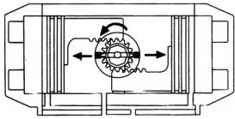
A↑ ↓B

When compressed air is input from port A, the left and right pistons move in opposite directions, the output shaft rotates counterclockwise, the valve is opened, and the air on the side of the two pistons is discharged from port B.

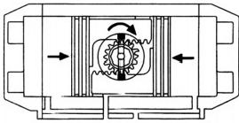
A ↓ 个B

When compressed air is input from port B, the left and right pistons move toward the center, the output shaft rotates clockwise, the valve is closed, and the air between the two pistons is discharged from port A

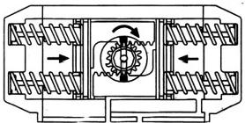

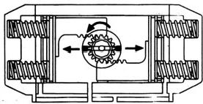
A↑ ↓B
A↓ 个B

When compressed air is input from port A, the left and right pistons move in opposite directions, the output shaft rotates counterclockwise, the valve is opened, and the air on the side of the two pistons is discharged from port B.

In case of air failure or power failure, the two pistons move toward the center due to the action of the spring, the output shaft rotates clockwise, the valve is closed, and the air is discharged from port A. If port B is connected to air, the valve can be opened by adding air.
1. For standard action, the rotation direction is clockwise to close the valve and counterclockwise to open the valve.
2. For the rotation direction with reversed piston assembly, it is counterclockwise to close the valve and clockwise to open the valve.

十一. Model Selection

First, determine the torque required for opening and closing the valve. Under normal operating conditions, a safety factor of 15~20% is recommended. For steam or non-lubricating liquid media, increase the safety factor to 25%; for non-lubricating slurry media, increase it to 40%; and for non-lubricating granular powder media, increase it to 80%. Then, based on the supply pressure used, refer to the output torque table of double-acting or single-acting actuators to obtain the accurate pneumatic actuator model. In the output torque table of single-acting actuators, the torque in the spring output torque end column is the torque for closing the valve.

Example of Double-Acting Actuator Selection

- Torque required for ball valve = 280 N·m
- Medium: Water
- Safety factor (20%): 280 × (1 + 20%) = 336 N·m
- Supply pressure = 4.5 Bar
- Refer to the double-acting output torque table, the model is JAT140D, and the output torque at 4.5 Bar supply pressure is 384.8 N·m

十二. Common Faults, Inspection and Troubleshooting Methods

Fault Phenomenon | Inspection Items | Solutions
Pneumatic valve fails to act | 1. Whether the solenoid valve is normal, whether the coil is burnt out, and whether the solenoid valve core is stuck by dirt | Replace the solenoid valve, replace the coil, and remove the dirt
 | 2. Supply air to the pneumatic actuator alone to check if the sealing ring and cylinder are damaged | Replace the damaged sealing ring and cylinder
 | 3. Impurities in the valve body jam the valve core | Remove impurities and replace damaged parts
 | 4. The handle of the manual mechanism is in the manual position | Turn the handle to the pneumatic position
Slow action, crawling | 1. Insufficient supply pressure | Increase supply pressure (0.4~0.7 MPa)
 | 2. Insufficient output torque of the pneumatic actuator | Increase the model specification of the pneumatic actuator
 | 3. The valve core or other valve parts are assembled too tightly | Reassemble and adjust
 | 4. The air supply pipeline is blocked, and the flow rate is too small. | Remove the blockage and replace the filter element
No signal from position switch | 1. Short circuit or open circuit in the power supply line | Overhaul the power supply line
 | 2. Incorrect cam position in the position switch | Adjust the cam to the correct position
 | 3. Damaged micro switch | Replace the micro switch

十三. Functions and Uses of Pneumatic Actuator Accessories

- Double-acting pneumatic actuator: Controls the opening and closing of the valve.
- Single-acting pneumatic actuator: Automatically closes the valve when the circuit, gas circuit is cut off or fails.
- Single solenoid-controlled solenoid valve: The valve opens or closes when powered, and closes or opens when power is off.
- Double solenoid-controlled solenoid valve: One coil energizes to open the valve, and the other coil energizes to close the valve, with memory function.
- Position switch: Transmits the open or closed position signal of the valve remotely.
- Electro-pneumatic positioner: Adjusts and controls the opening of the valve (i.e., medium flow) according to the magnitude of the current signal (4~20 mA).
- Electro-pneumatic converter: Converts current signals into air pressure signals and is used with pneumatic positioners.
- Pneumatic positioner: Controls the opening of the valve for adjustment and control according to the magnitude of the pneumatic signal (0.02~0.1 MPa).
- Pneumatic (Three-unit pneumatic service unit): Reducing valve, filter, and lubricator. It stabilizes, cleans the air supply and lubricates moving parts.
- Manual mechanism: Used to operate the opening and closing of the valve when the circuit, gas circuit is cut off or fails.

十四. Ordering Information

- Pneumatic actuator: Double-acting, single-acting (normally closed or normally open).
- Valve working pressure, medium used, operating ambient temperature, and hard or soft seal.
- Solenoid valve: Double solenoid-controlled solenoid valve, single solenoid-controlled solenoid valve, operating voltage, and whether it is explosion-proof.
- Signal feedback: Mechanical switch, proximity switch, operating voltage, output current signal, explosion-proof type;
- Positioner: Pneumatic positioner, electro-pneumatic positioner, current signal, air pressure signal, electro-pneumatic converter, explosion-proof type;
- Three-unit pneumatic service unit
- Manual device
- Special customization
- It should be specified whether the accessories are domestic or imported.

